Legends for GRAM PPV/NPV charts

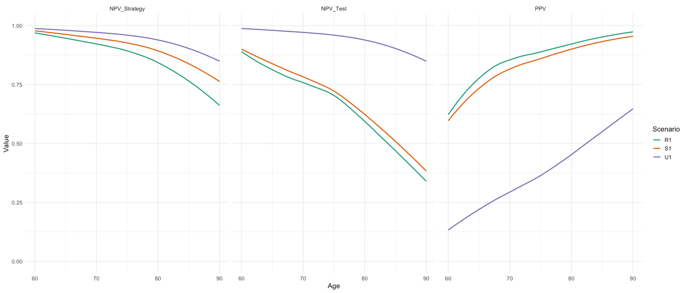

The figure shows test performance results of 3 different cognitive testing strategies in a microsimulation of cognitive impairment and dementia. All scenarios use the same cognitive test (the BHA). U1 is annual universal testing, where everyone 60 and older receive an annual BHA. S1 is annual selective testing: there is a systematic pre-screening of cognitive concerns each year, and those who report concerns get a BHA each time. R1 is annual reactive testing, where testing relies on spontaneous self-report of cognitive concerns. Since those with cognitive concerns are more likely to report them than those without concerns, more restrictive strategies tend to lead to higher prevalence of impairment among those selected for testing. Thus, R1 has the greatest PPV and smallest NPV out of the three scenarios, as positive results are more likely to be TPs than FPs, and negative results are more likely to be FNs than TNs. NPV of the overall strategy also accounts for those not receiving the BHA. In U1, NPV of the strategy is equal to the NPV of the test among those tested, because everyone is tested. In R1 and S1, when those who are not tested are included as default negative, the NPV of the strategy is higher than the NPV of the test among those tested, because of the inclusion of a larger proportion of TN compared to FN among those not tested. For all scenarios, PPV grows and NPV drops over time as the general population prevalence increases.

